Release Note

Quality Inspection Module

# 1 Basic Details

|  |  |
| --- | --- |
| Customer |  |
| Customer Name | N/A |
| Customer PM  (Where appropriate) | N/A |

|  |  |
| --- | --- |
| Release Control |  |
| Reference No. | MA005 |
| Author | Marcus Ambra |
| Release | 2005-01R |
| Risk Level | High |
| Release Date | 04/05/2020 |
| Release Media | FOB |
| Release Reason |  |
| Database Version | Dynamics NAV 2018 (11.0.358115) |
| Package Name | NA |
| Delivery Method | NA |
| Customer Approval  (Delivery) | NA |

|  |  |
| --- | --- |
| Work Detail |  |
| Project Name | Kill Session |
| Project Manager | NA |
| Project Phase | Project |
| Person (Developer/Consultant) | Marcus Ambra |
| Functional Area | Purchase Order / Manufacturing Order |
| Reviewer/Approver (Peer/Senior) |  |
| Design Reference | NA |
| Development Release note no. | NA |

# 2 Overview

I have created the bespoke module called “Quality Inspection” in NAV.

2.1 SETUP

2.1.1 – Purchase & Payables Setup

Define the “No. Series” for “Quality Inspection Order” and “Posted Quality Inspection”

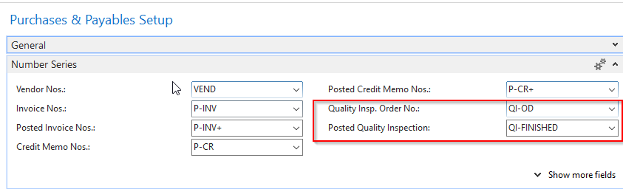

2.1.2 – Location card:

In the location card you can define the bin code for the Quality Inspection. This bin is normally defined as Quarantine or QA which you can segregate the item in your warehouse.

The system will create a positive adjustment to the Bin Code informed in the field below:

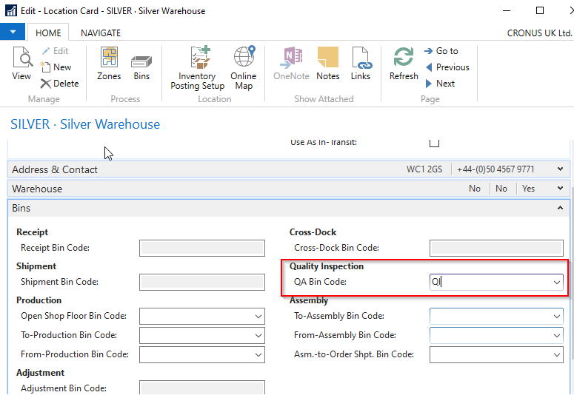

2.1.3 – Item Card

Quality Inspection field: Here you can define if the item should be inspected when a “purchase receipt” or Prod. Order Output” is posted.

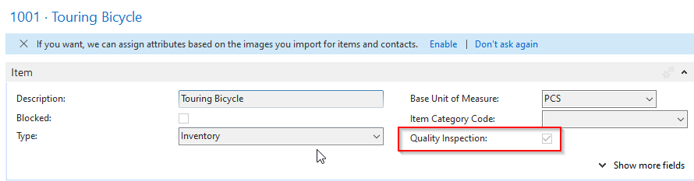

2.1.4 – Vendor Card

In the vendor Card you can define if all items from this specific vendor must be inspected once the purchase receipt is posted.

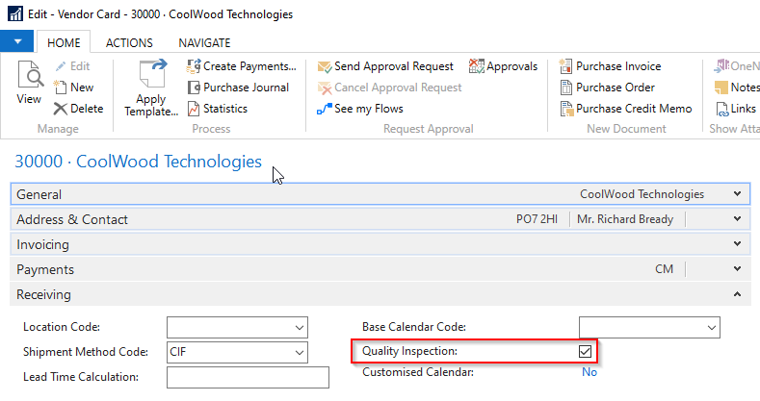

2.2 PROCESS:

2.2.1 – Purchase Order

There is a Boolean field in the “Purchase Line” called “Quality Inspection” which is automatically set as True if the item or Vendor has been set to true.

You can also mark this field manually if you want to create a Quality Inspection for an item which hasn’t been previously defined to be inspected.

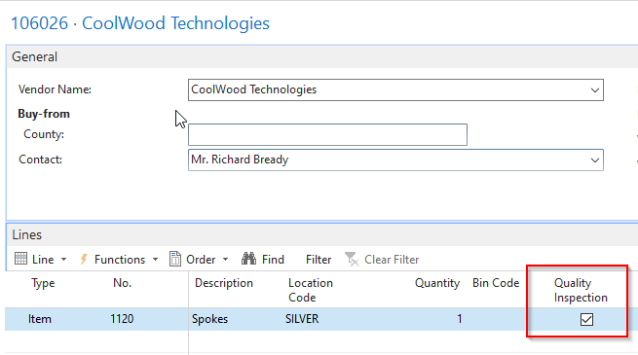

Once the “Purchase Receipt” is posted, then the Quality Inspection entry is created:

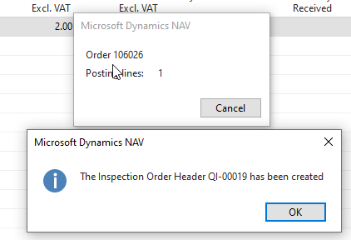

If you navigate in the Warehouse Entry created from the Purchase Receipt, you will see the Positive Adjustment has been posted to the bin Code “QA” which was defined in the Location Card.

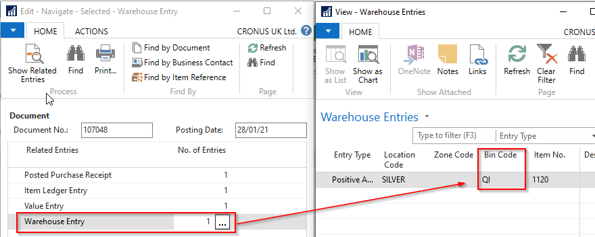

**Item Ledger Entry:**

There is a FlowField which shows the Quality Inspection linked to the Item ledger Entry:

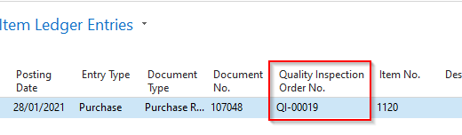

In the item card you can also see how many quantities is/are in quality inspection:

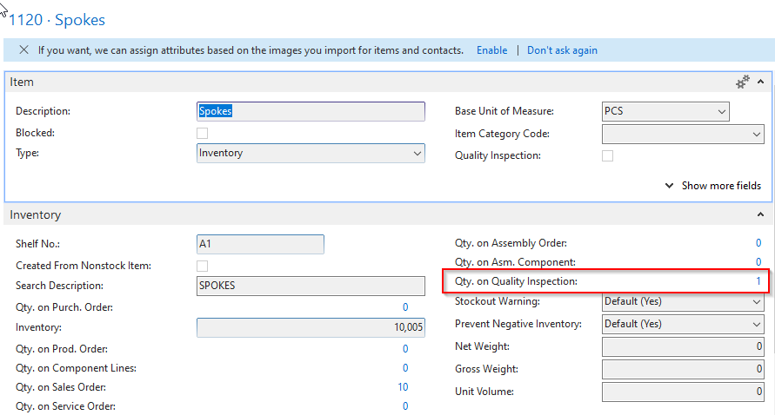

There is a validation which does not allow you to use the item, if the available item is on Quality Inspection.

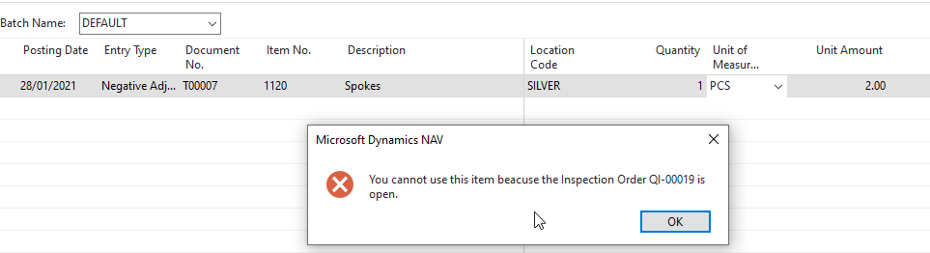

**2.2.2 – Quality Inspection Order**

As can be seen below, the quality inspection was created, and it is open for inspection.

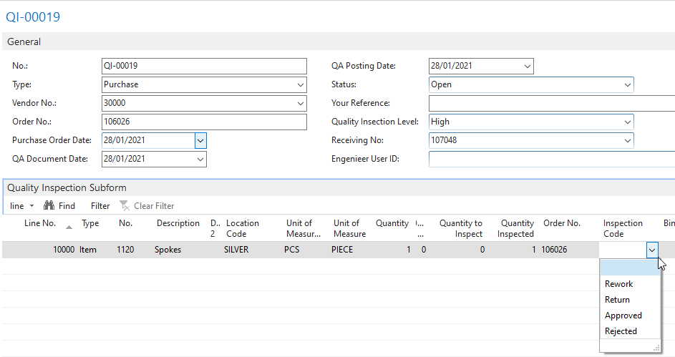

You can add comments in the line:

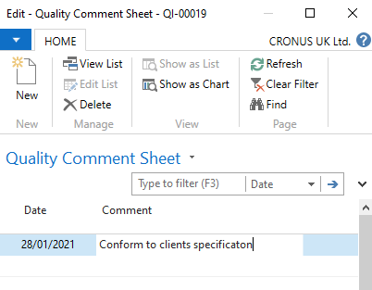

**Quality Check List:**

Here you can include all relevant information about the quality inspection process.

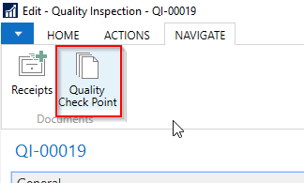

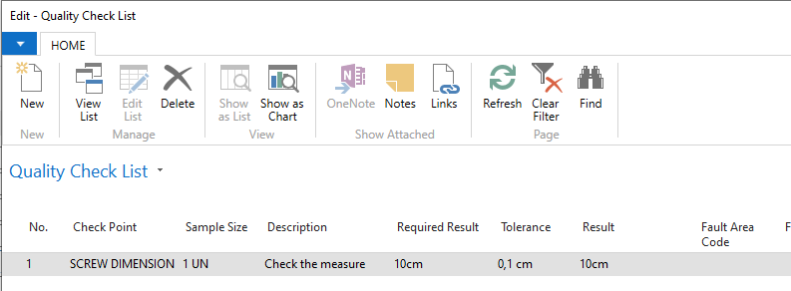

Once the Inspection Order was approved, then you can change the status to Closed

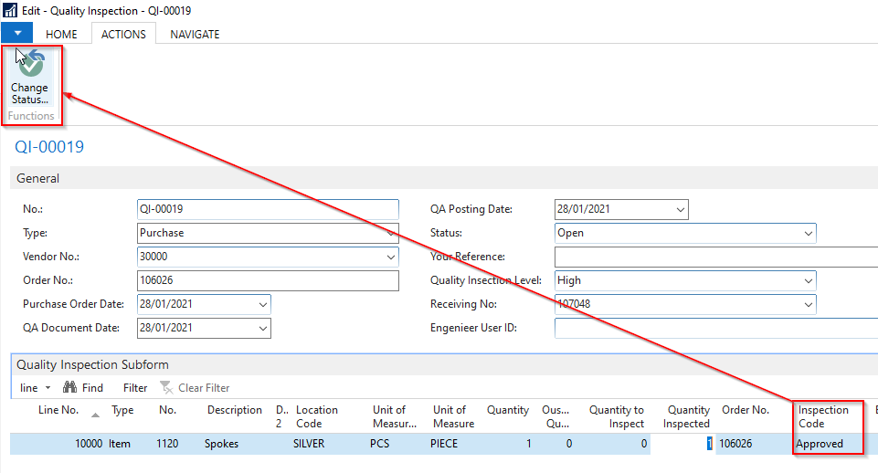

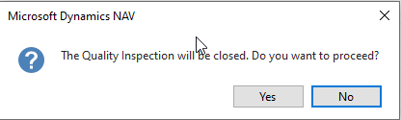

Once the status has been changed, the Quality Inspection has been transferred to Finished Quality Inspection List

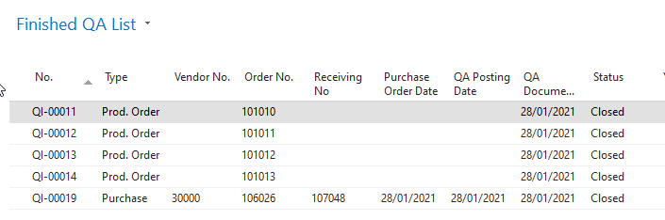

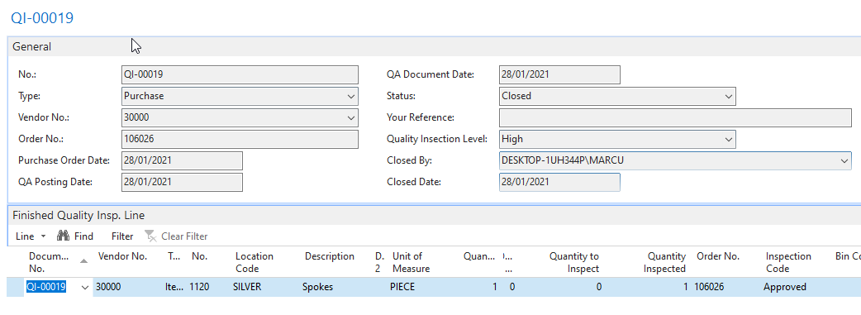

**Production Order**

The same process applies to production orders, which the Quality Inspection will be created once the Output journal is posted

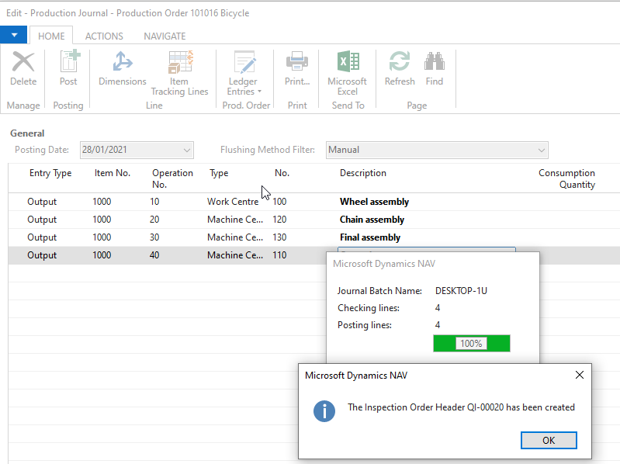

# 3 Technical Details

## 3.1 Summary of Solution Modifications

### 3.1.1 Modifications

The following new modifications have been completed and tested:

|  |  |  |  |
| --- | --- | --- | --- |
| Reference | Source | Type | Summary |
|  |  |  |  |

## 3.2 Object Changes

Important Note: If there is any discrepancy between the Original Object details and the corresponding Object Details in your database, please do not import them, but inform immediately with details.

### 3.2.1 Object Verification

|  |  |
| --- | --- |
| Source database object changes were developed in |  |
| Date development objects compared to live | 04/05/2020 |

### 3.2.2 Existing

|  |  |  |  |  |  |  |
| --- | --- | --- | --- | --- | --- | --- |
| Object Type (table, form, etc.) | Object ID | Name | Modified | Version | Date | Time |
|  |  |  |  |  |  |  |

### 3.2.3 New

|  |  |  |  |  |  |  |
| --- | --- | --- | --- | --- | --- | --- |
| Object Type (table, form, etc.) | Object ID | Name | Modified | Version | Date | Time |
|  |  |  |  |  |  |  |

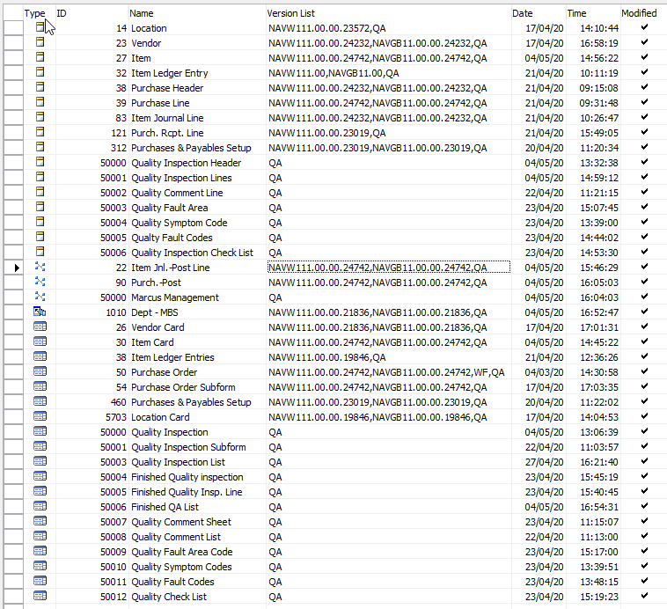

## 4. Post Deployment Testing Steps

Please ensure your testing is proportionate to the level of risk.

### 4.1 To Test Code

### 4.2 To Test Data Fix

Not required

# 5 Quality Assurance

## 5.1 Testing Completed

NA

## 5.2 Code Review / Testing

|  |  |  |
| --- | --- | --- |
|  | Name | Date completed |
| Unit Test completed by | Marcus Ambra |  |
| Code Review completed by | Marcus Ambra |  |
| Testing completed by | Marcus Ambra |  |
| UAT testing completed successfully | Marcus Ambra |  |

# 6 Sign Off

|  |  |  |  |
| --- | --- | --- | --- |
| Action | Name | Signature | Remarks |
| Released By | Marcus Ambra | Marcus Ambra |  |
| Approved By |  |  |  |

All objects/changes moved in to your live environment by yourself or otherwise, are considered complete and approved. Any further changes required after this stage may be considered a new change request.

Please be aware that objects/changes not moved into your live environment within a reasonable amount of time, upon completed user acceptance testing, may cause conflict with other objects/changes.